**Part I: Hardware Components**

Fill in the following **terms** and explain their **purpose** with an example of a current specification for the term that is appropriate. (e.g. Brand, size, speed…)

**Terms**

CPU   
RAM   
Optical Storage Device

Motherboard

Computer Bus

Graphics Card

Flash/SSD Drive

Magnetic Hard drive

Cache Memory

Provide your answers in the table below.

|  |  |
| --- | --- |
| **Term** | **Purpose / Description** |
| CPU | The primary component of a computer which processes instructions. It runs the operating system and applications.  1.2Ghz |
| RAM | Small memory chips which form a module. The modules are installed into the mother board. 4 x 8GB |
| Optical Storage Device |  |
| Motherboard |  |
| Computer Bus |  |
| Graphics Card |  |
| Flash/SSD Drive |  |
| Magnetic Hard Drive |  |
| Cache Memory |  |

What are the ***typical units of measurement*** for the following devices?

|  |  |
| --- | --- |
| **Component** | **Typical Units of Measurement** |
| **CPU** |  |
| **Memory**  **(eg. RAM)** |  |
| **Monitor** |  |

**Part 2: Fill in the blanks**

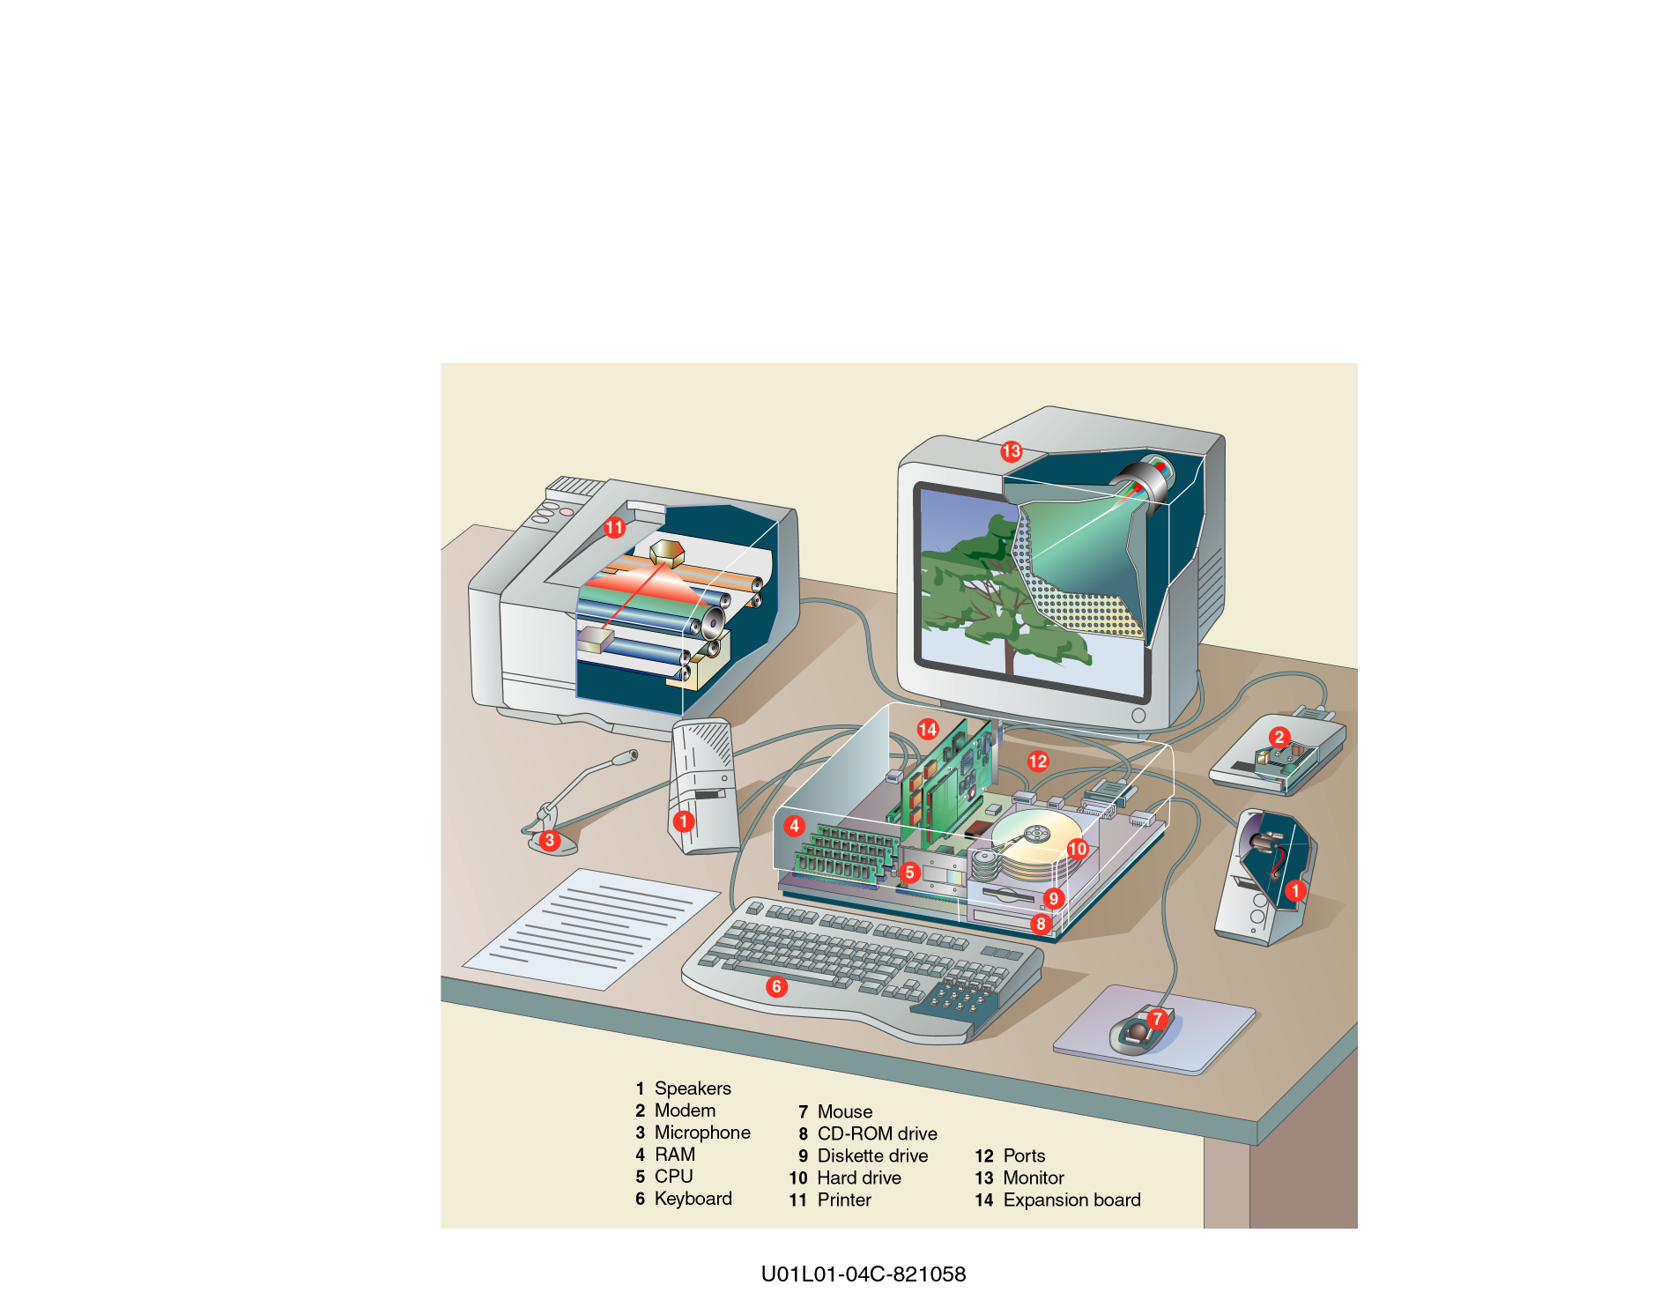

Examine the picture above and fill in the chart below.

You must **write the** **number and the name** of the component for full marks!

|  |  |
| --- | --- |
| **Input Devices** | **Output Devices** |
|  |  |
|  |  |
|  |  |
|  |  |

**Complete the following paragraph using the proper terminology**

When I turn off the computer, data stored in the _______________________ is erased, but if I remember to save data on the ________________________________ I can retrieve my data the next time power on the computer. The ______________________ is like the **central nervous system** of the computer, while the _________________ is like the **brain** of the computer.